Experiment 1
Install and configure Python, OpenCV, and Jupyter Notebook for image processing tasks
Roll no. 4117

- Installations:
Commands Used:
- pip install opencv-python
- pip install notebook
- jupyter notebook

- Python code:
import cv2
image=cv2.imread('nature.png')
cv2.imshow('Sample Image', image)
cv2.waitKey(0)
cv2.destroyAllWindows()

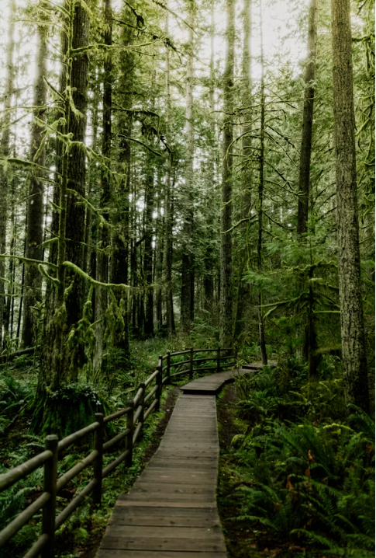
- Viva Questions:
